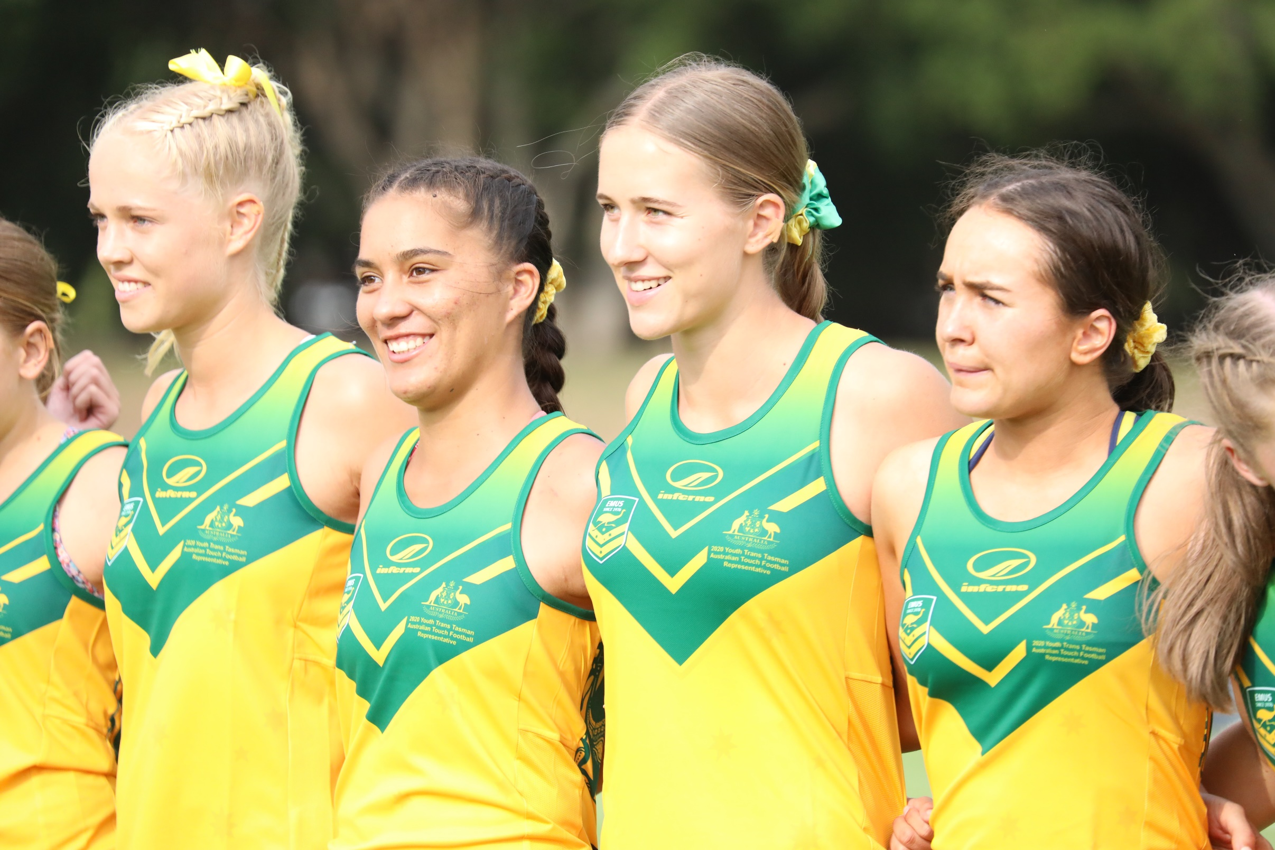

April 2020

Touch Football Australia

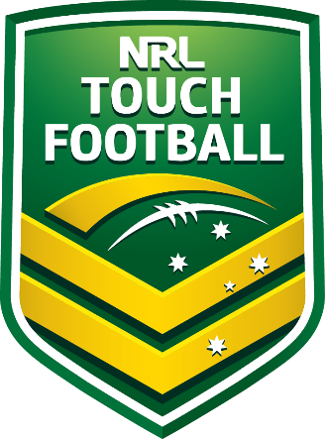

Touch Football Australia

Apparel Licensing Program

Application Form

TFA Apparel Licensing Program

Request for License (Official Licensee – NRL Touch Football)

Thank you for your interest in becoming a licensee under the Touch Football Australia (TFA)
(NRL Touch Football) Apparel Licensing Program.

The NRL Touch Football Licensing Program controls the use of TFA Intellectual Property across all apparel for teams nationally*. As such, it is a requirement that all companies /organisations /manufacturers wishing to use TFA IP apply for a non-exclusive license.

This involves the rights to the following:

1) A non-exclusive license for the period commencing 1 May 2020 – 31 April 2023, to affix NRL Touch Football approved logo(s) to apparel items of affiliates, club teams, entities and state teams participating in NRL Touch Football (TFA) affiliated matches / competitions including the following items:

- On Field Playing Tops
- On Field Playing Shorts
- Caps
- Off Field Apparel

Requests will be reviewed against the relevant criteria of this document.

NRL Touch Football makes no representation or warranty that this document provides all of the information required by your company and encourages those wishing to submit a proposal to make their own queries and assessments.

Any costs incurred in the preparation and submission of proposals or otherwise in connection with this document will be borne by the proposer.

If successful, a license DOES NOT grant approval for manufacturers/suppliers to sell event or online merchandise. This is managed via separate agreement with TFA and State Bodies.

*Note: TFA has sublicensed the NSW NRL Touch Football logo to New South Wales Touch Association and Queensland NRL Touch Football logo to Queensland Touch Football. Both organisations have their own separate licensing programs and uniform guidelines separate to this document / program.
Frequently Asked Questions

Q: Why do we need licensed approval to use TFA IP when we have used it before?
A: TFA has a responsibility to control the unauthorised use of our IP to protect our brand image and to ensure the correct application of logos etc. There have also been numerous organisations pass off as a partner of TFA which is not in the commercial interests of the sport and/or TFA.

Q: Do we need a license to supply Touch Football uniforms?
A: No, TFA IP is not compulsory on social team uniforms so you can continue to supply customers without a license. However, many customers do request to use the NRL Touch Football logo and multiple TFA run competitions and events mandate the use TFA IP on uniforms, so a license provides the opportunity to supply these teams/customers

Q: How many licenses are awarded under this program?
A: A total of ten (10) companies will be provided a license.

Q: Our company has a NSWTA and/or QTF license, does this permit us to use TFA IP?
A: No, state-based licensing programs only apply to that particular state’s logos / IP. If you wish to use TFA IP you will need to apply for a national license in addition to any current state arrangements.

Q: What logos and IP are relevant to this program?
A: Please refer to the addendum at the rear of this document for a list of relevant logos / IP

Q: I cannot answer many of the application questions. How should I handle this and how will it affect my chances of getting a license?
A: All questions must be answered to the best of your ability. If you feel that a question does not apply to you, please answer “N/A” and include a brief explanation of why.

Q: Will TFA sign a confidentiality agreement?
A: No, you should not include any information or material with your license application that you want to keep confidential.

Q: How long will the entire application process take?
A: Allow four to six weeks for a response to your application.

A representative from NRL Touch Football will be available to answer any queries regarding the request. Please submit any queries (in writing initially) to the attention of Tim Wyld – General Manager Commercial tim.wyld@touchfootball.com.au

Requests will be assessed against the following criteria:

- Capacity to fulfil high volume orders
- Proven history of major teamwear accounts with sporting bodies and Touch Football affiliates
- Reputation and financial strength
- Product quality
- Capacity and demonstrated ability to abide by all relevant Fair Work Practices
We look forward to receiving your completed application. All submissions must be submitted electronically to: tim.wyld@touchfootball.com.au

Applications Close: 5.00pm (AEST) 30 April 2020

Please note that only official licensed apparel and or merchandise may carry the logos and marks of Touch Football Australia (TFA), and marks registered by TFA or ALRC. TFA vigorously protects the ownership of its intellectual property and will, as appropriate, take legal action against any unauthorised use of these symbols or any unauthorised attempt to associate any company, product or service with TFA or any related marks or logos.
Nothing in this application form shall give rise to any legal or professional relationship between the applicant and TFA. Completion and submission of this application form does not grant the applicant any rights or license to use any intellectual property of TFA or its related bodies corporate. TFA will review and evaluate application forms and may or may not choose to contact applicants to discuss their application and the products disclosed therein.

License Terms

1. IP Ownership
The NRL Touch Football logo(s) is a registered trademark of the Australian Rugby League Commission (ARLC). The ARLC grants TFA full permission under this program to manage the rights of this IP on their behalf under the strategic partnership agreement between the two parties.

1. Financial Terms
An annual license fee of $5,000 (+ GST) is payable by successful applicants.

2. Duration
Non-Exclusive licenses are valid for a three-year period commencing 1 May 2020. A new application must be received to continue to use TFA IP outside of this timeframe.

3. Compliance
Successful licensees must comply with the TFA Visual Guidelines and TFA Uniform Guidelines. Copies of both documents will be made available for successful licensees.

Licensee’s must have an appreciation and understanding of the image that NRL Touch Football wishes to promote and the connection between the image and the quality, standard and consistency required.

TFA IP is compulsory on representative team uniforms at selected TFA competitions and events (tournaments). This includes but is not limited to:
- NRL Touch Premiership team uniforms
- National Touch League and National Youth Championships Team Uniforms
- Any team uniforms for use in any state league, program or event that requires either the NRL Touch Football or specific event logo which is owned by TFA (I.e. State of Origin, VT League etc.)
4. Changes
Changes to TFA IP may occur during the life of license agreements. TFA will notify licensees in writing in
the event of any changes or updates to logos and other IP. TFA will not be held liable for any costs
associated with changes or updates during the life of the agreement.

Application Form

Section 1: General Details

1. Name of Business
Click or tap here to enter text.

2. Please list your ABN or ACN
Click or tap here to enter text.

3. Year Established
Click or tap here to enter text.

4. Street Address
Click or tap here to enter text.

5. Postal Address (if different to Street Address)
Click or tap here to enter text.

6. Name and Title of Main Contact
Click or tap here to enter text.

7. Main Contact Phone Number
Click or tap here to enter text.

8. Website Address
Click or tap here to enter text.

9. Previous name(s) and address(es) for this business and/or businesses operated by any principal of this company within the last 5 years:
Click or tap here to enter text.

Section 2: Company Information

9. Please identify the legal form of your organization (please tick one of the following):
☐ Corporation
☐ Partnership
☐ Limited Partnership
☐ Sole Partnership
☐ Trust
☐ Other (Please Specify) Click or tap here to enter text.

10. Please list the name, address and phone number of all owner and/or partners of the company below:
Click or tap here to enter text.

11. What other products are currently manufactured / sold by your company?

☐ Other Sporting and/or School / Business Uniforms
☐ Compression Garments
☐ Merchandise
☐ Promotional Items
☐ Equipment
☐ All of the Above

12. What are the trade/brand names of the products currently manufactured / sold by your company?
Click or tap here to enter text.

13. Please detail any other licenses (particularly sport and lifestyle brand licenses) held by your company:
Click or tap here to enter text.

14. Please detail any current or previous apparel experience your company has provided National Sports Organizations
Click or tap here to enter text.

Section 3: Manufacturing & Distribution Information

15. Where does your company manufacture (please tick one of the following):
Choose an item.
Please provide the name and location of the factories that manufacture your goods:
Click or tap here to enter text.

16. Please describe your company’s quality control program (including compliance with any Fair Work Act, third-party regulations or testing standards, including ISO standards)
Click or tap here to enter text.

17. Does your company currently have distribution throughout Australia?
Choose an item.

18. If successful, will your company distribute licensed products to retailers?
Choose an item.
If yes, please specify
Click or tap here to enter text.

19. Does your company have its own graphic design team?
Choose an item.
If no, please provide details below of how your company currently completes design requirements for customers
Click or tap here to enter text.

20. Please provide details of the intended advertising, marketing and promotion your company would undertake if you were successful in obtaining a TFA Apparel License
Click or tap here to enter text.

Section 4: Other Information

21. Have there been any voluntary or involuntary liquidation or administration of the companies listed in section 1?
Choose an item.
If yes, please attach a separate sheet providing all details including disposition

22. Have any claims been filed against the companies listed in section 1 for trademark, copyright or patent infringements or for product liability?
Choose an item.
If yes, please attach a separate sheet providing all details including disposition

23. Have any of the companies listed in section 1 been subject to proceedings by the trade practices commission or similar entity?
Choose an item.
If yes, please attach a separate sheet providing all details

24. Does your company have a history of working with affiliated Touch Football associations / bodies? Please list the associations that you currently work with (if relevant)
Click or tap here to enter text.

Supplementary Items
Please include the following items in your submission:
- An electronic copy of your sales / product catalogue and/or ranges
- Additional pages to supplement any answer above
- Any additional information you wish TFA to consider
- Digital images / artwork of each proposed product
- All previous designs/artwork including TFA IP (if applicable)
Please do not send samples or hard copies of catalogues etc.

Please review your application to be sure that all questions have been answered. If an item does not apply please write N/A.

Submitting Your Application

By signing the below, you certify that the information provided in this application is accurate as of the time of submission and that you are authorized by your company to submit this application.

Signature:

Name: Click or tap here to enter text.
Date: Click or tap here to enter text.

Please submit your completed License Application Form electronically to Tim.wyld@touchfootball.com.au

Applications Close: 5.00pm (AEST) 30 April 2020

Addendum 1: TFA (NRL Touch Football) Intellectual Property

The following (but not limited to) logos are the intellectual property of TFA and are applicable under this non-exclusive apparel license (i.e. a license is required to use):

- NRL Touch Football Logo
- NRL Touch Premiership Logo
- Touch Football Australia Corporate Logo (and state executions of this)
- NRL Touch Football ACT Logo
- NRL Touch Football NT Logo
- NRL Touch Football SA Logo
- NRL Touch Football TAS Logo
- NRL Touch Football WA Logo
- NRL Touch Football VIC Logo
- Touch Football Specialised Logo
- All Abilities Logo
- National Touch League Logo
- National Youth Championships Logo
- National Schools Cup Logo
- NRL League Touch Logo
- TFA Centrally Managed Competitions Logos (I.e. City Touch, Darwin Touch, Albert Park, Deakin etc.)
- TFA Administered and Delivered Program Logos (i.e. Switch, Youth in Touch etc.)
- TFA State Event Logos (i.e. WA State Championships, WA Junior State Championships etc.)
- TFA State League Competition Logos (i.e. VT League logo, Super Series Logo, State League Logo etc.)

